Real-Time Graph AML Detection Platform

Money laundering is a network problem. Illicit funds are rarely moved in a single suspicious transaction; they are split, layered and recombined across many accounts, channels and institutions until each individual step looks ordinary. Conventional transaction-monitoring systems evaluate transactions one at a time, per channel, often in overnight batches. They generate large volumes of alerts that investigators must then piece together by hand, while the genuinely suspicious pattern ,the journey of the money ,stays hidden across system boundaries.
This proposal describes a real-time, graph-based Anti-Money Laundering (AML) detection platform. Every transaction, whether it originates internally (core banking, card and POS switch, digital channels), externally (interbank rails, wallets, remittance and partner APIs) or offline (branch and agent files, end-of-day extracts), is captured the moment it is recorded, converted into a single canonical event, and merged into a live GraphDB graph of customers, accounts, transactions, devices and counterparties. Each new transaction triggers pattern-matching queries on the neighbourhood of the accounts it touched. When a defined money-laundering typology is matched ,a circular flow, a rapid pass-through by a new mule account, a ring of customers sharing one device ,the platform scores it, raises an alert within seconds and hands investigators a visual, explainable picture of the network behind it.
The solution combines three capture mechanisms ,Change Data Capture (CDC) from source databases, a manual reconsciliation by running single individual queries and/or a batch ETL loader for offline files ,on an Apache Kafka streaming backbone. A GraphDB provides native graph storage, Cypher pattern matching and the Graph Data Science (GDS) library for community detection, centrality and similarity analysis. A detection service evaluates a configurable typology library, a scoring service ranks results, and a case-management workspace supports triage, investigation, escalation and reporting, with every analyst decision fed back to tune the rules.
The expected outcomes are faster detection (seconds instead of next day), materially fewer false positives because alerts are raised on network patterns rather than isolated thresholds, shorter investigations because the evidence is already assembled as a graph, and coverage of offline and external flows that are often invisible to channel-specific systems.

THE PROBLEM
- Transaction-at-a-time rules - Traditional monitoring often evaluates transactions, accounts, amounts, counts and velocity individually. Suspicious activity that is deliberately distributed across multiple accounts can therefore remain below individual thresholds.
- Channel silos - Cards, cash, transfers, mobile money and other channels may be monitored independently. A movement of funds that begins in cash, passes through an account and ends in a mobile wallet may not be recognized as one connected flow..
- Batch delay - Monitoring may operate periodically or overnight against previously recorded transactions. By the time an alert is generated, funds may already have moved through several accounts or channels.
- Noise - Rule-based monitoring can generate large numbers of alerts that require manual investigation. This consumes investigator capacity and can delay attention to genuinely suspicious activity.
- Manual investigation - networks rebuilt by hand in spreadsheets.Investigators often have to combine transactions, accounts, customers and counterparties manually to understand how money moved. Reconstructing the complete network can take hours or days and may produce inconsistent investigative evidence.
- Relational-query complexity - Questions involving multiple hops across accounts and transactions can require complex joins and repeated queries. As the number of connected entities increases, investigating the full transaction network becomes increasingly difficult at production scale.
- Limited network context. - Traditional monitoring may identify that an individual transaction is unusual without immediately considering the wider network around it. Shared devices, counterparties, identifiers, circular flows and other relationships can therefore remain hidden until an investigator manually connects them.
THE SOLUTION
- Transaction sources.
- Existing transaction systems remain unchanged and continue processing transactions normally. These include core banking, card and POS systems, digital channels, external payment rails and partners, and offline or batch sources.
- Transaction capture layer.
-Completed transactions are captured outside the transaction-processing path. For the common Oracle 19c transaction store, the preferred approach is an approved external log-based CDC mechanism that captures committed database changes without requiring AML processing inside Finacle transaction scripts. External channels that already provide APIs or event feeds are connected through an AML integration gateway, while systems without real-time interfaces continue to use controlled batch ingestion.
- Canonical event and integration layer.
Captured changes are converted into a common AML transaction event containing the relevant transaction, account, customer, channel, counterparty and reference information. The integration layer handles correlation, enrichment, validation and deduplication before publishing the event to the streaming platform.
- Streaming backbone. (AUTOMATIC & MANUAL RECONCILLIATION)
Apache Kafka provides durable, scalable and replayable transport between transaction capture and AML processing. Events are partitioned for parallel processing, while stream processors perform real-time enrichment and maintain the ordering and state required for detection. Failed or malformed events are isolated through a dead-letter mechanism. In addition to the automated streaming path, the platform provides a controlled manual reconciliation mechanism that can execute approved read-only queries against selected source tables and columns when required. The returned data is transformed into the same canonical events used by the streaming pipeline and applied to the graph through an upsert/reconciliation process, allowing missing, outdated or inconsistent entities and attributes to be refreshed or corrected without rebuilding the graph or modifying the source transaction systems.
- Live graph layer.
GraphDB maintains the continuously updated network of customers, accounts, transactions, counterparties, devices and other relevant identifiers. New events update only the affected portion of the graph rather than requiring repeated reconstruction of the entire transaction history. Graph Data Science provides additional capabilities for community detection, centrality, similarity and other network analysis.
- Real-time detection and scoring.
Each committed transaction event is evaluated against the typologies affected by the new activity. Detection focuses on relevant graph neighbourhoods and active investigation states rather than repeatedly scanning the entire graph. Matching patterns are scored according to configurable risk factors and thresholds.
- Alert and case management.
When a defined typology is satisfied, the platform creates an alert containing the transactions, accounts, relationships, timestamps and other evidence that produced the result. Investigators can then review the network, record decisions, escalate cases and generate regulatory or management reports.
- Transaction lifecycle handling.
Subsequent events such as reversals, cancellations, cheque returns or adjustments are captured as new lifecycle events rather than deleting the original transaction. The graph preserves the historical record while the detection layer recalculates affected typologies and alerts based on the transaction's current economic status.
Design Principles

- Non-intrusive capture.
AML processing remains outside the Finacle transaction-processing path. The preferred Core Banking integration uses external log-based CDC against the approved Oracle 19c change stream rather than adding AML API calls to individual transaction menus.
- Event-driven and incremental.
Committed changes are continuously published to Kafka and processed as events. Detection operates on the affected accounts, relationships and active typology states instead of waiting for end-of-day processing or repeatedly scanning the full transaction population.
- Channel-independent.
Transactions originating from Core Banking, mobile money, cards, POS, external rails, partner APIs or batch files are converted into the same canonical AML event model, allowing activity across channels to be evaluated as one network.
- Scalable under burst load.
Kafka partitions and parallel stream consumers allow the platform to absorb high transaction bursts without requiring a synchronous AML call for every Core transaction. Processing capacity can be scaled independently of the banking transaction system.
- Explainable by construction.
Every alert is linked to the underlying transactions and graph relationships that caused the typology to match. Investigators can therefore see the money flow and the specific evidence supporting the alert.
- Auditable and reversible.
Transaction events are retained as an immutable history. Reversals, returns and corrections generate new events that update the effective state rather than erasing the original activity, preserving a complete investigation trail.

SOLUTION ARCHITECTURE
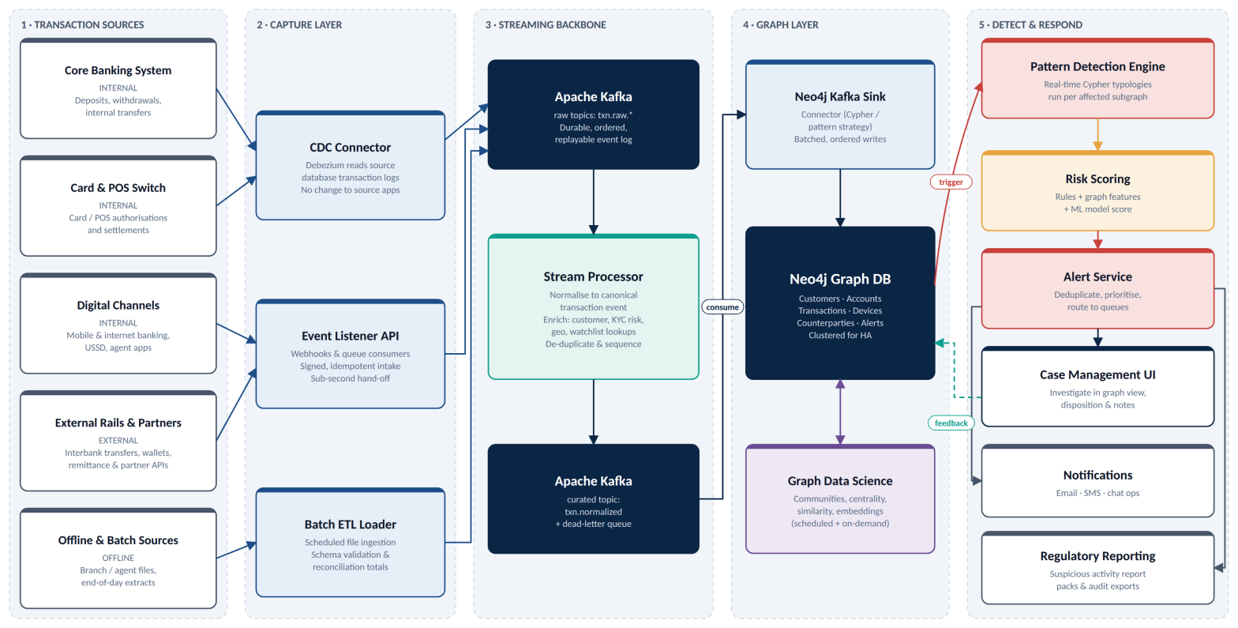
Five layers: sources → capture → streaming → graph → detect & respond. Dashed line: analyst outcomes fed back to the graph.

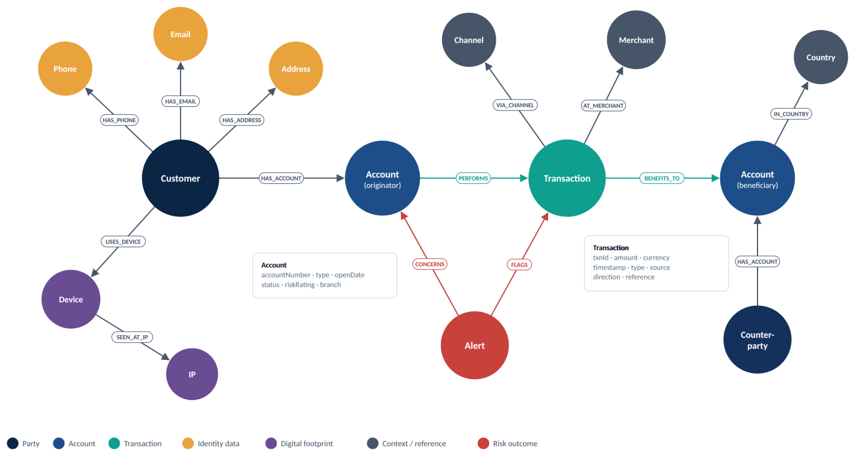
Figure 2: Graph data model ;parties, accounts, transactions, identity and risk

Example pattern queries & Typology
The queries below show how typologies are expressed in Cypher. In production each query is parameterised, runs from the triggering account, and returns the matching subgraph for the alert.

Circular flow (adapted from the GraphDB transaction-ring reference)
MATCH path = (a:Account {accountNumber: $accountNumber})
-[:PERFORMS]->(first:Transaction)
((t1:Transaction)-[:BENEFITS_TO]->(mid:Account)-[:PERFORMS]->(t2:Transaction)
WHERE t1.timestamp < t2.timestamp
AND duration.between(t1.timestamp, t2.timestamp).hours < 72
AND 0.80 <= t2.amount / t1.amount <= 1.00){2,5}
(last:Transaction)-[:BENEFITS_TO]->(a)
WHERE first.timestamp >= datetime() - duration('P7D')
AND size(apoc.coll.toSet(mid)) = size(mid) // every intermediary distinct
RETURN path LIMIT 10

Fan-in structuring
MATCH (c:Account {accountNumber: $accountNumber})
<-[:BENEFITS_TO]-(t:Transaction)<-[:PERFORMS]-(src:Account)
WHERE t.timestamp >= datetime() - duration('PT24H')
AND t.amount >= $threshold * 0.85 AND t.amount < $threshold
WITH c, count(DISTINCT src) AS sources, count(t) AS credits, sum(t.amount) AS total
WHERE sources >= 5
OPTIONAL MATCH (c)-[:PERFORMS]->(out:Transaction)
WHERE out.timestamp >= datetime() - duration('PT48H')
AND out.amount >= total * 0.8
RETURN c.accountNumber, sources, credits, total,
count(out) > 0 AS consolidatedOut

Rapid pass-through (mule behaviour)
MATCH (acc:Account {accountNumber: $accountNumber})
<-[:BENEFITS_TO]-(tin:Transaction)
WHERE tin.timestamp >= datetime() - duration('PT24H')
MATCH (acc)-[:PERFORMS]->(tout:Transaction)
WHERE tout.timestamp >= tin.timestamp
AND tout.timestamp <= tin.timestamp + duration('PT2H')
WITH acc, tin, sum(tout.amount) AS outWithin2h, count(tout) AS outCount
WHERE outWithin2h >= 0.9 * tin.amount
AND duration.inDays(acc.openDate, date()).days <= 30
RETURN acc.accountNumber, tin.amount, outWithin2h, outCount

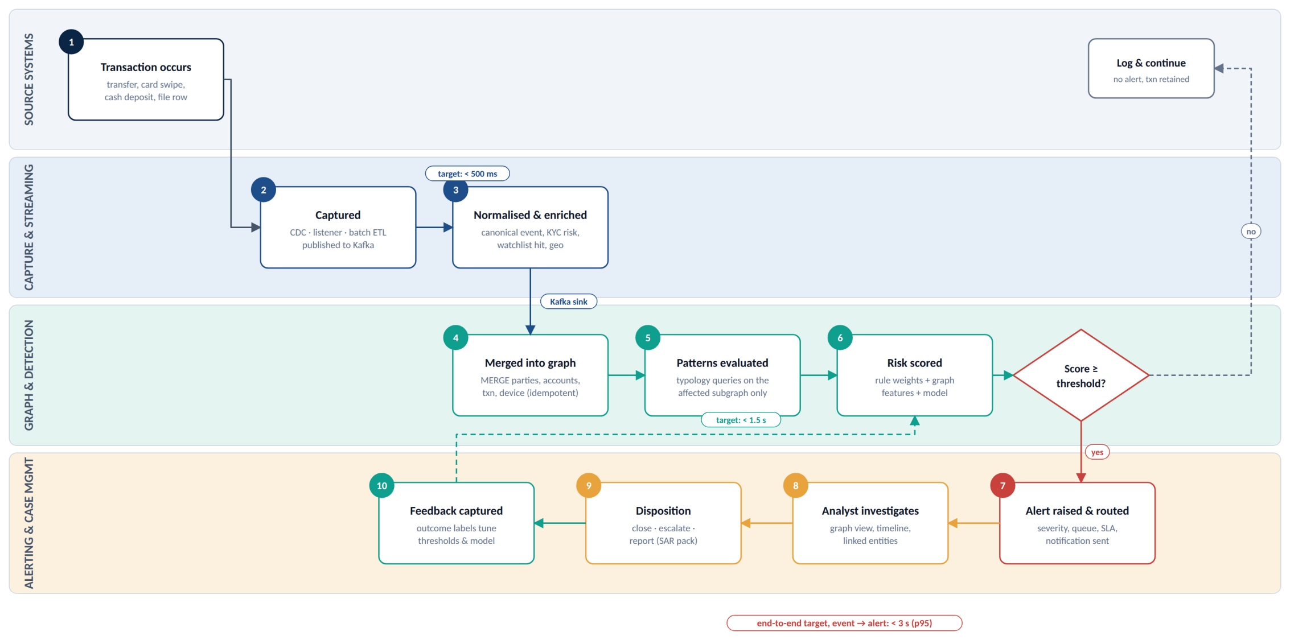
Figure 3: End-to-end real-time workflow from transaction to disposition

